NOVEMBER NEWSLETTER 2022

Primary News

Enrolling Now for Prep 2023
This year, our Prep class was already full before the new school year commenced. With all the new enquiries and enrolments that we have already received, the School has decided to run two Prep classes on Tuesday, Wednesday and Thursday. To avoid disappointment of your child missing out on their desired days, we advise you to enrol as soon as possible. Enrolment forms may be dropped off at the School office or emailed to Mrs Xanthoudakis at xanthoudakise@steuphemia.nsw.edu.au

Primary News Vacancies
Applications are now open for Kindergarten 2023. If you are an existing parent and have a child ready to start school next year, please ensure that you fill out our application form and return it to an administration officer in Reception.

Children enrolling for Kindergarten 2023, must turn five years of age before 31 July 2023. Students enrolled in our Prep class, have automatic entry into Kindergarten and do not need to complete any additional forms.

The School also has vacancies in other grades. If you have any friends, neighbours or relatives interested in enrolling their children, please ask them to contact the school for an Enrolment Form or download it from our website.

Year 6 Transition Lessons – Thursday 3 November
The last of our High School transition lessons will be held on Thursday 4 November. Students will have the opportunity to participate in a Maths relay, participate in a Science experiment and explore texts studied in English.

Prep and Kindergarten Transition
Our Prep and Kindergarten Transitions will be held on four separate days in November. Students attend these visits to familiarise themselves with the School, and to allow them to experience the School organisation and routine. All sessions will be held from 9:00-10:30am.

Kindergarten Transition Sessions
Tuesday 8 November - Prep students and their parents
Thursday 10 November – New students and their parents
Tuesday 15 November – Prep students
Wednesday 16 November – New students

Year 7 Meet and Greet BBQ – Thursday 10 November
A Meet and Greet BBQ will be held for Year 7 students and parents from 6:00pm-8:00pm on the school grounds. A BBQ will be held from 6:00pm-7:00pm. Parents are to assemble on school grounds near the canteen, followed by a formal presentation in the Church hall from 7:00pm-8:00pm. We look forward to meeting our new students for 2023 and their parents.

Gelato Day – Thursday 22 November
Year 6 will hold their final fundraising event of the year. All students from Prep to Year 6 will have the opportunity to purchase a gelato on the day. A separate flyer will be issued at a later date, with all the necessary information.

Prep Graduation – Thursday 24 November
The Prep Graduation Ceremony will be held on Thursday 24 November beginning at 9:30am in the School hall. During the ceremony, the Prep students will receive their gifts and certificates and entertain their parents with songs. Morning tea will be provided.

Kindergarten Graduation – Thursday 24 November
The Kindergarten Graduation Ceremony will be held on Thursday 24 November beginning at 1:30pm in the School hall. During the ceremony, the Kindergarten students will receive their gifts and certificates for completing their first year of ‘big school’.

Prep to Year 2 Infants Christmas Concert – Thursday 1 December
Parents and caregivers are invited to attend the Infants Christmas Concert which will be held at 1:00pm in the School hall. The students will be participating in Christmas and Greek Dancing performances. Students will be supervised by their class teachers in their classrooms until the conclusion of the concert. Parents are advised that the students will be released from supervision at the conclusion of the concert only.

Year 6 Graduation Dinner – Friday 2 December
Each year we hold a Graduation Dinner to celebrate the end of Primary School for our Year 6 students. The Graduation Dinner is planned as a family event, and we encourage all Year 6 parents to attend and share the celebration with us. The Graduation will be held at the Emporium Function Centre on Friday 2 December from 6:30-11:00pm. Completing Year 6 is a significant milestone for students as they move onto High School. We look forward to a great evening reminiscing the wonderful journey that our Year 6 students have had and celebrating their final days as part of the Primary School.

Primary Sports Assembly – Monday 5 December
Parents and caregivers are invited to attend our annual Primary Sports Assembly for Years 3-6 on Monday 5 December at 1:00 pm in the Church hall. It is an event that celebrates the students who have achieved excellent accomplishments in Sport. Other awards will also be presented on the day. Students will also entertain us with Christmas songs and Greek Dancing. All students are to be in full school uniform.

Primary Presentation Day - Tuesday 6 December
Parents and caregivers are invited to attend our annual Primary Presentation Day Ceremony for Years 3-6 on Tuesday 6 December at 11:00 am in the Church hall. It is an event that celebrates the students who have achieved excellent academic accomplishments in all Key Learning Areas. The new Prefects and Captains will be inducted, and the Dux of the Primary will be awarded.

Excursions
Prep, Kindergarten and Year 1 Excursion
On Monday 14 November, Prep, Kindergarten and Year 1 will be attending an excursion to Hurstville Entertainment Centre and Rotary Park, Riverwood. The cost of the excursion is $37. Please forward the permission slip to the class teacher and transfer the amount to the school office by Friday 4 November. Students will need to bring their own packed recess, lunch and a water bottle in a small backpack. Students are to wear their full summer sports uniform, including their school hat. In the event of wet weather, the excursion will proceed.

Year 5 Camp
Year 5 will be attending an excursion to The Blue Mountains and The Bathurst Goldfields from Monday 14 to Tuesday 15 November. The excursion is a key component of the History topic, ‘The Australian Gold Rush’. The cost of the excursion is $335 per student. Please forward the permission slip to the class teacher and transfer the amount to the school office by Monday 7 November. Year 5 will be departing on Monday 14 November at 7.45am sharp. Students must arrive at school at 7.30am. Year 5 will be returning on Tuesday 15 November at approximately 6.00pm, depending on traffic conditions. Students must wear their summer sports uniform on the day of departure.

Year 2
On Monday 5 December, Year 2 will be attending an excursion to the Royal Botanical Gardens. The excursion links to the Term 4 HSIE topic, 'Our Connections with Places'. Students will experience a hands-on day bursting with fun games and activities. They will enjoy investigating the importance of different places to people and living things and discuss the places they live in and examine varying environments. The cost of the excursion is $56. Please forward the permission slip to the class teacher and transfer the amount to the school office by Friday 2 December. Students will need to bring their own packed recess, lunch and a water bottle in a small backpack. Students are to wear their full summer sports uniform, including their school hat. In the event of wet weather, the excursion will be cancelled.

Sports News
PSSA Summer Gala Days – Friday 11 November and Friday 25 November
The PSSA Summer Gala Days for Term 4 will be held on: Friday 11 November and Friday 25 November. Boys Cricket will be held at Jim Ring Reserve. Boys T-Ball and Softball will be held at Kinch Reserve. Girls T-Ball and Softball will be held at O’Neil Park and Boys and Girls Basketball will be held at Bankstown Basketball Stadium, Condell Park.
The games will be running the entire day beginning from 9:30am and ending at 2:30pm. Students will be transported to their venues by buses and return to school by 3:10pm. In the event of wet weather, all PSSA games will be cancelled. Students who are not in the PSSA competition, will be participating in school sporting activities.

Last Month

School Fun Run
On Wednesday 12 October, we were fortunate enough to hold our School Fun Run. Due to the rain, we were not able to go to Garrison Point Reserve, however, we were lucky enough to hold the event in our School playground. Prep to Year 6 enjoyed a fun day of running under the amazing inflatables and some of our classes even got to meet Chase the Cheetah, the School Fun Run mascot. Overall, we raised just over $20 000. After the prize incentive payment, our School was left with over $11 000. This money will be used to purchase products for our Primary School.
Our winning class was Prep once again, raising just over $5000. Congratulations to the Prep class who will be having a pizza party for their efforts.

Other notable mentions are the following students who all raised over $1000. These students were: Raymond - Prep, Aari – Prep, Amelia KB, John - 2A, and Xilin - 2A. We thank them and their generous family and friends who donated.

Overall, we thank all the students who raised money for the School Fun Run. We now await our amazing prizes.
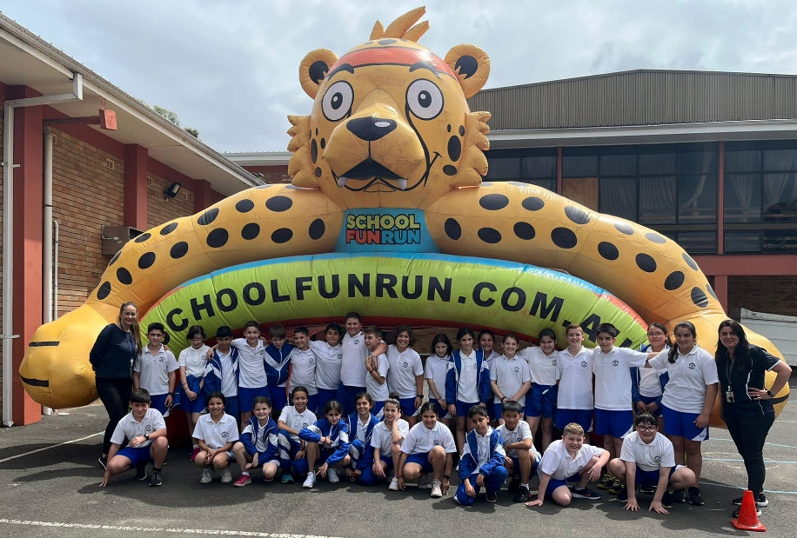

Book Fair

Our annual Book Fair was held last month, and many students visited the fair with excitement. Many amazing books and lots of stationery were sold. We thank all the students who came in and bought the amazing products sent to us by Scholastic Book Fairs.

We raised over $7000 and after paying for the book purchases, we were left with $2350 incentive points to spend on resources at the Scholastic Book Club.

A notable mention to the following students who purchased a book and kindly donated it to our school library - Ophelia Anastasiadis from 5B and Michael-John Zghaib, also from 5B.
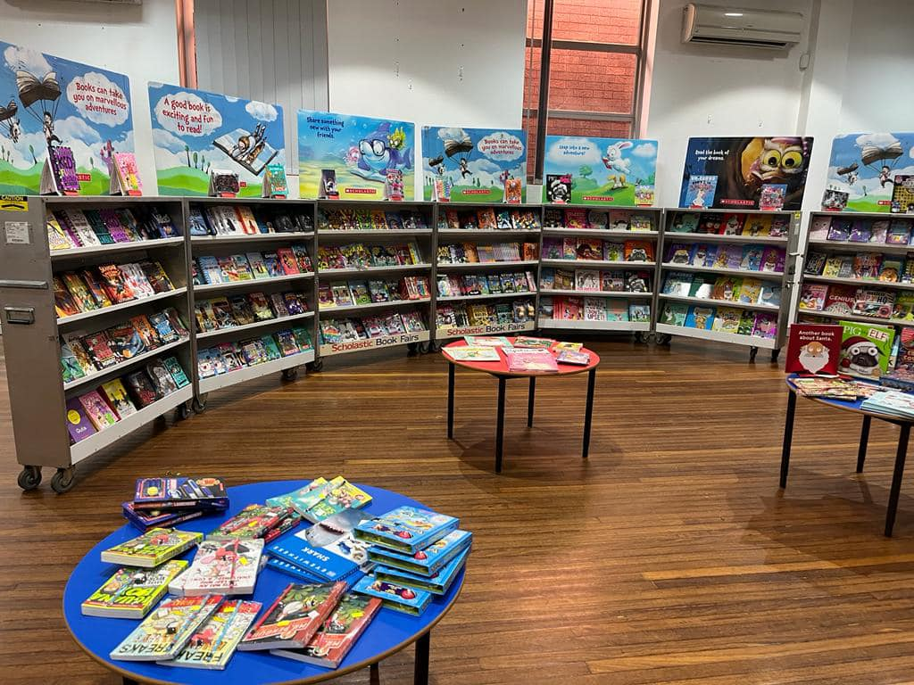
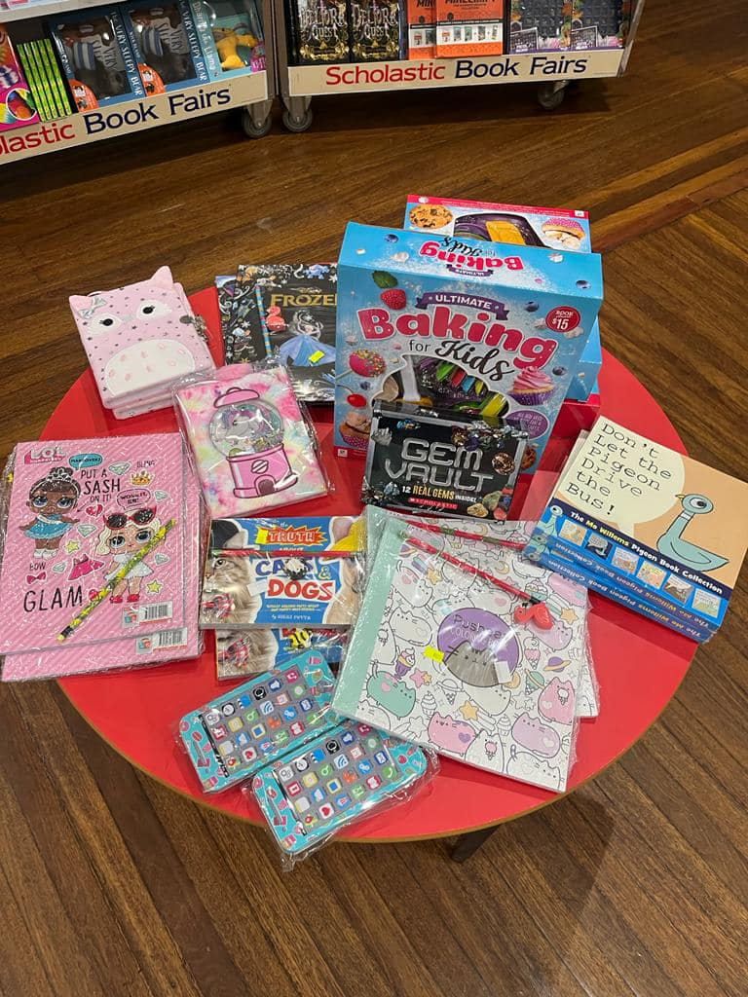

Book Week
