FIRST IN STATE SERBIAN CONTINUERS

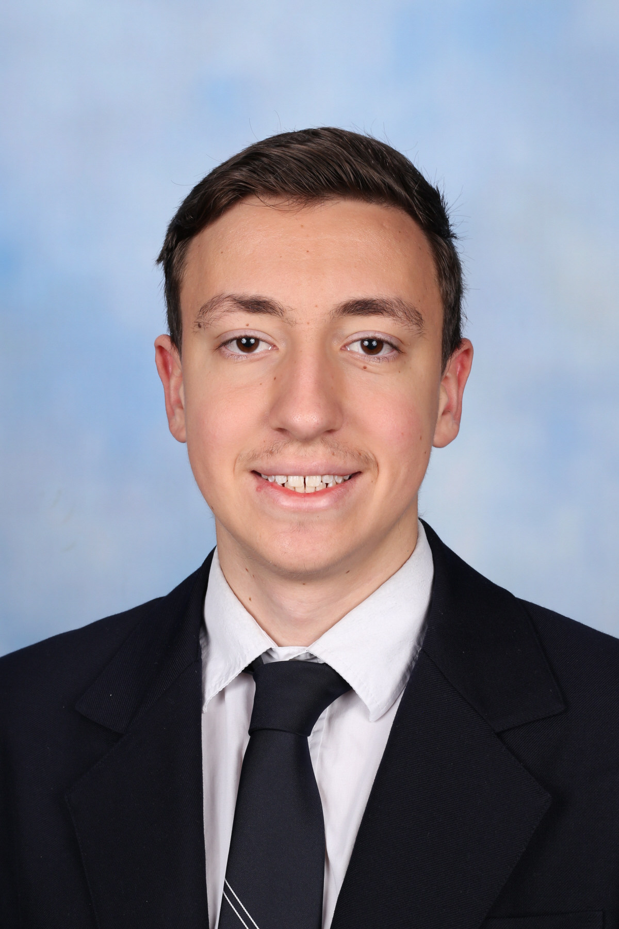

We are absolutely thrilled to share the fantastic news that David Stanisavljevic has secured the title of First in the State for Serbian Continuers.

His remarkable achievement is a testament to his dedication and the exceptional standard of excellence here at St Euphemia College.

David’s journey to the top has been nothing short of inspiring. His passion for learning and commitment to mastering the Serbian language truly set him apart. This achievement reflects his perseverance and consistent hard work and shines a light on the supportive educational environment St Euphemia College cultivates.

Congratulations, David!

